Explore the life and work of Yayoi Kasuma
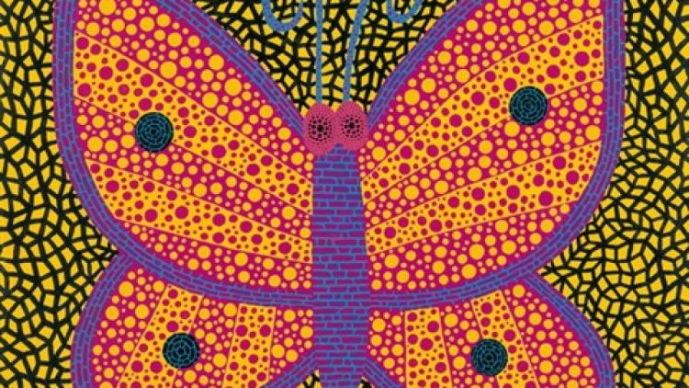
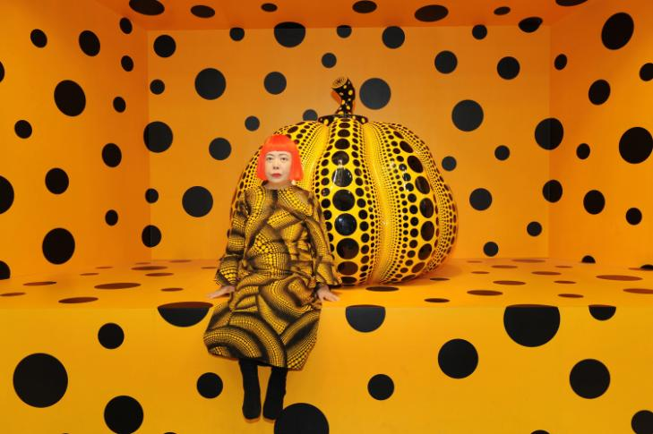

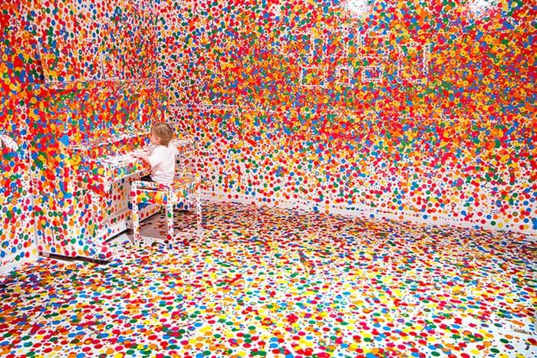

Yayoi Kasuma is a Japanese artists, who you can see is obsessed with dots! You can learn more about her by following these links: https://www.tate.org.uk/kids/explore/who-is/who-yayoi-kusama https://www.youtube.com/watch?v=YvVABrPWxSI
- • How do you feel when you look at her work?
- • What does it remind you of?

Today you are going to create your own spotty piece of art.
Watch this video to see how one teacher created her own spotty pumpkin based on the ones that Yayoi creates:
https://www.youtube.com/watch?v=LhvTkI3vZWU
Now it’s your turn. You need to create a bright picture made up of spots. You can draw a pumpkin too but you might want to choose a different object or vegetable.
Top Tips:
- - Try to choose two contrasting colours so your picture stands out as much as one of Yayoi’s.
- - Be precise, this will take time and focus.
Here are some examples from other primary school students to help you.
